LETTER OF GRATITUDE FOR ICSCE 2016
Professors, Scientists, Researchers and Scholars,
It is our pleasure to make the conclusion that the 2016 International Conference of Sustainability on Civil Engineering (ICSCE 2016) was a great success. Many of you including scientists, professors, experts, scholars, and practitioners both domestic and international have contributed in different ways to turn this great event into a smoothly running high-level international academic communication forum with many interesting presentations, posters and a great atmosphere for fruitful discussions, scientific interaction and networking.
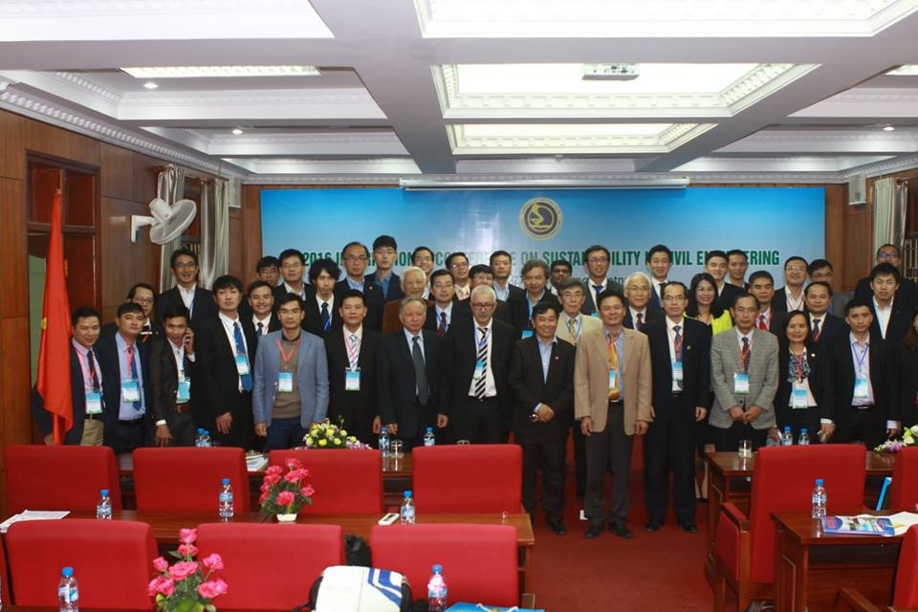
On behalf of the Civil Engineering Faculty of University of Transport and Communications (UTC) and also the Chairman of Local Organizing Committee, we would like to express our sincere thanks and appreciation to you all for your cooperation, contribution and attending the ICSCE 2016 on 26th and 27th November, 2016 at the UTC.
On such very special occasion, I wish you all the best of health, great success and happiness.

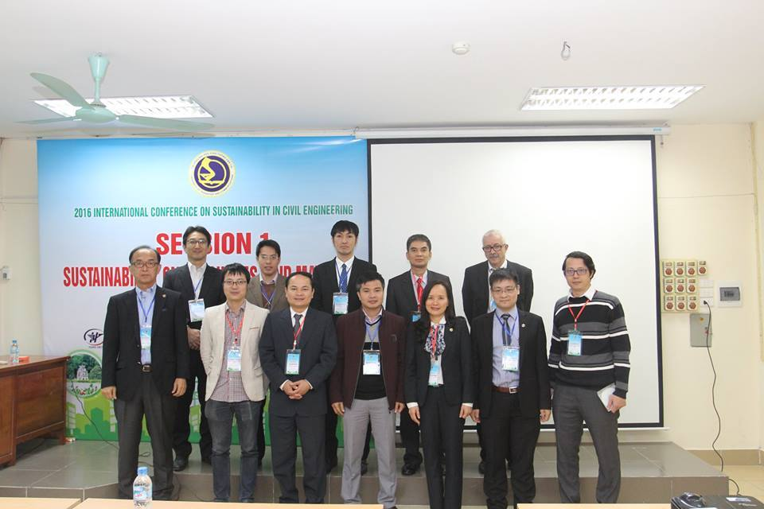
And we also do hope that you continue to be engaged with us to keep challenging for sustainable civil engineering as the slogan of the Conference. Please stay tuned for upcoming events by keeping in touch.
We are looking forward to welcoming you back to Civil Engineering Faculty, and UTC in Vietnam.

Prof. Dr. Le Hai HA
Chairman of the LOC of ICSCE 2016
Dean of Civil Engineering Faculty
University of Transport and Communications

